|  |  |
| --- | --- |
| NAME | SRIRAM PRASATH T |
| NM ID | 56AD23AE9E94878B8B8464109C34B61A |
| COLLEGE NAME | SARANATHAN COLLEGE OF ENGINEERING |
| PROJECT TITLE | BUILDING A WEBSITE USING CANVA |
| CATEGORY | DIGITAL MARKETING |
| DEPARTMENT | ELECTRONICS AND COMMUNCATION ENGINEERING |
| NM TEAM ID | NM2023TMID00402 |

Email id:cheekycrisps@gmail.com

Password:Prasanna0710

Facebook Bussiness

Page:https://www.facebook.com/profile.php?id=61550639097909

STEP – 1 : NAVIGATION

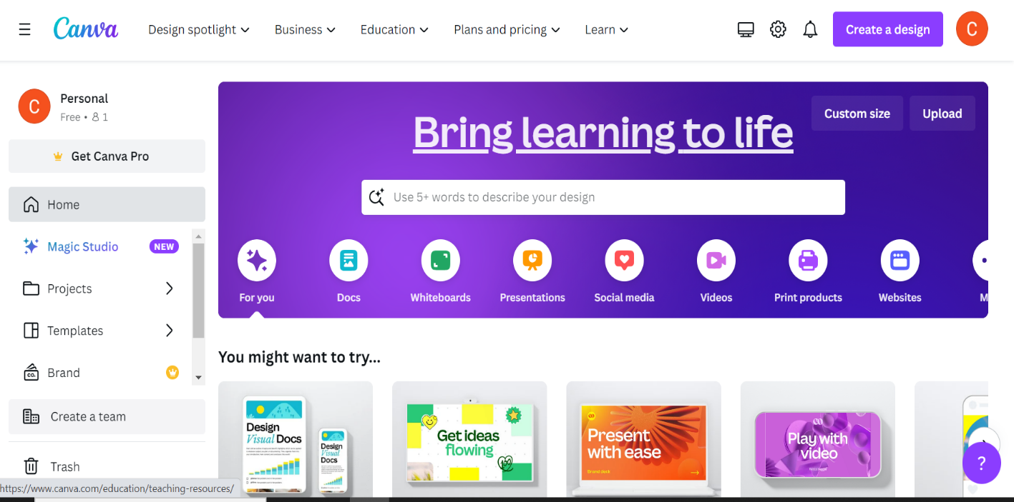

STEP-2 : CREATING A DESIGN

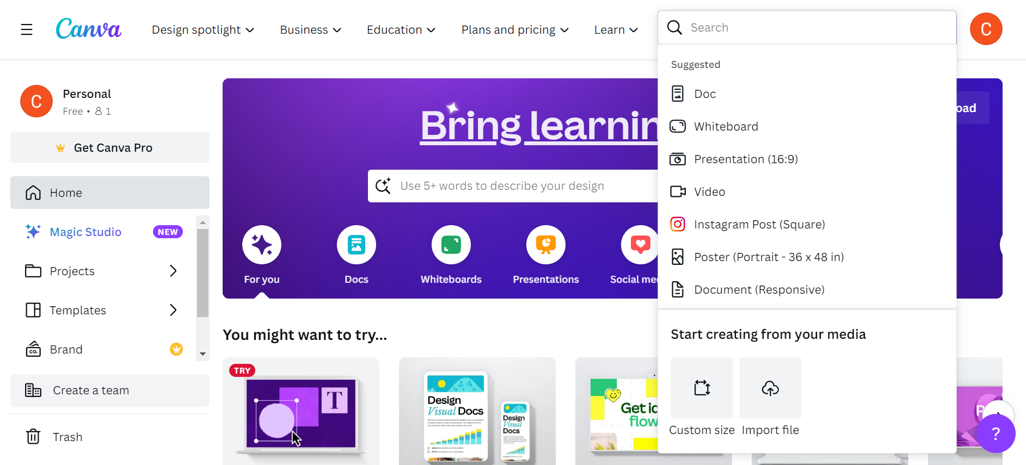

STEP-3 : SEARCH AND CLICK WEBSITE

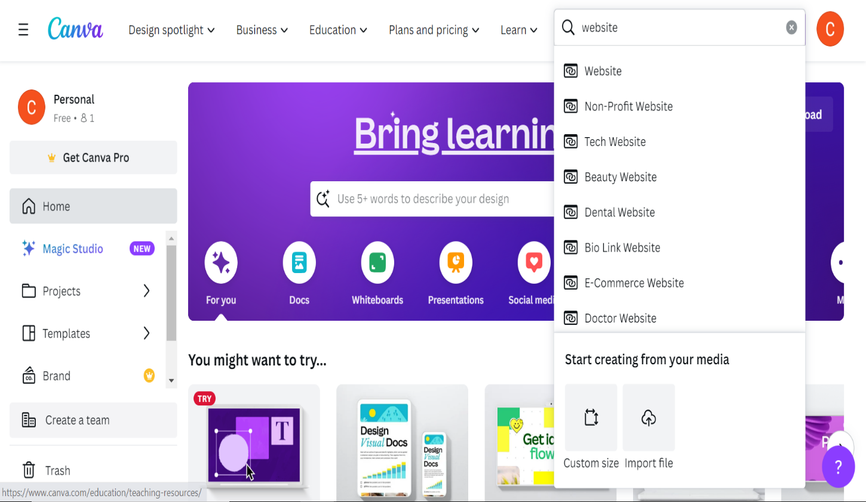

STEP-4 : SEARCH AND CLICK ONLINE STORE

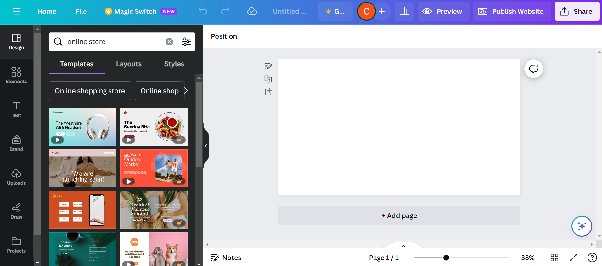

STEP- 5 : CHOOSING THE DESIGN

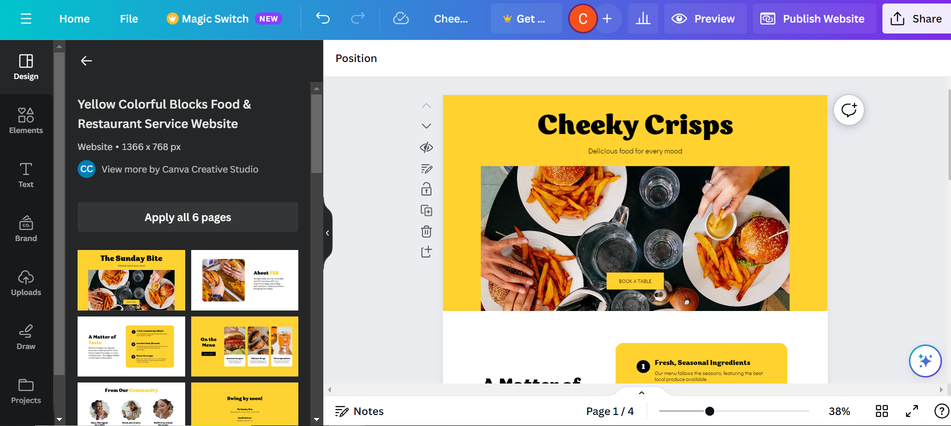

STEP – 6 : CHANGE BACKGROUND AND ADD GRADIENT

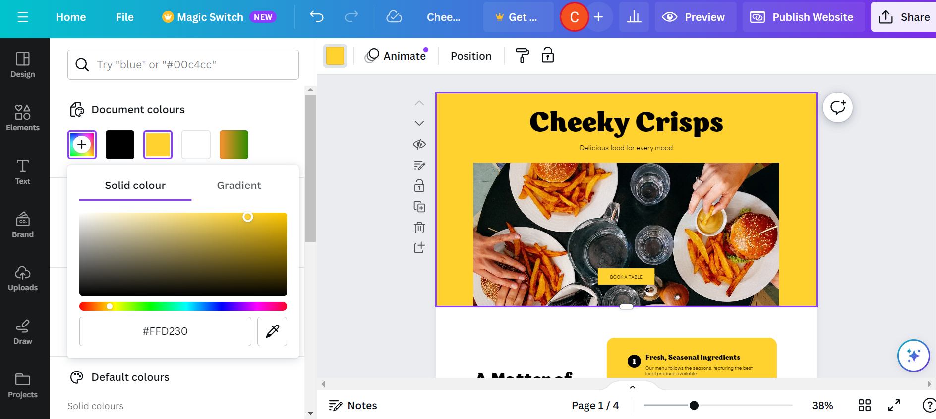

STEP – 7 : CREATING A WEBSITE

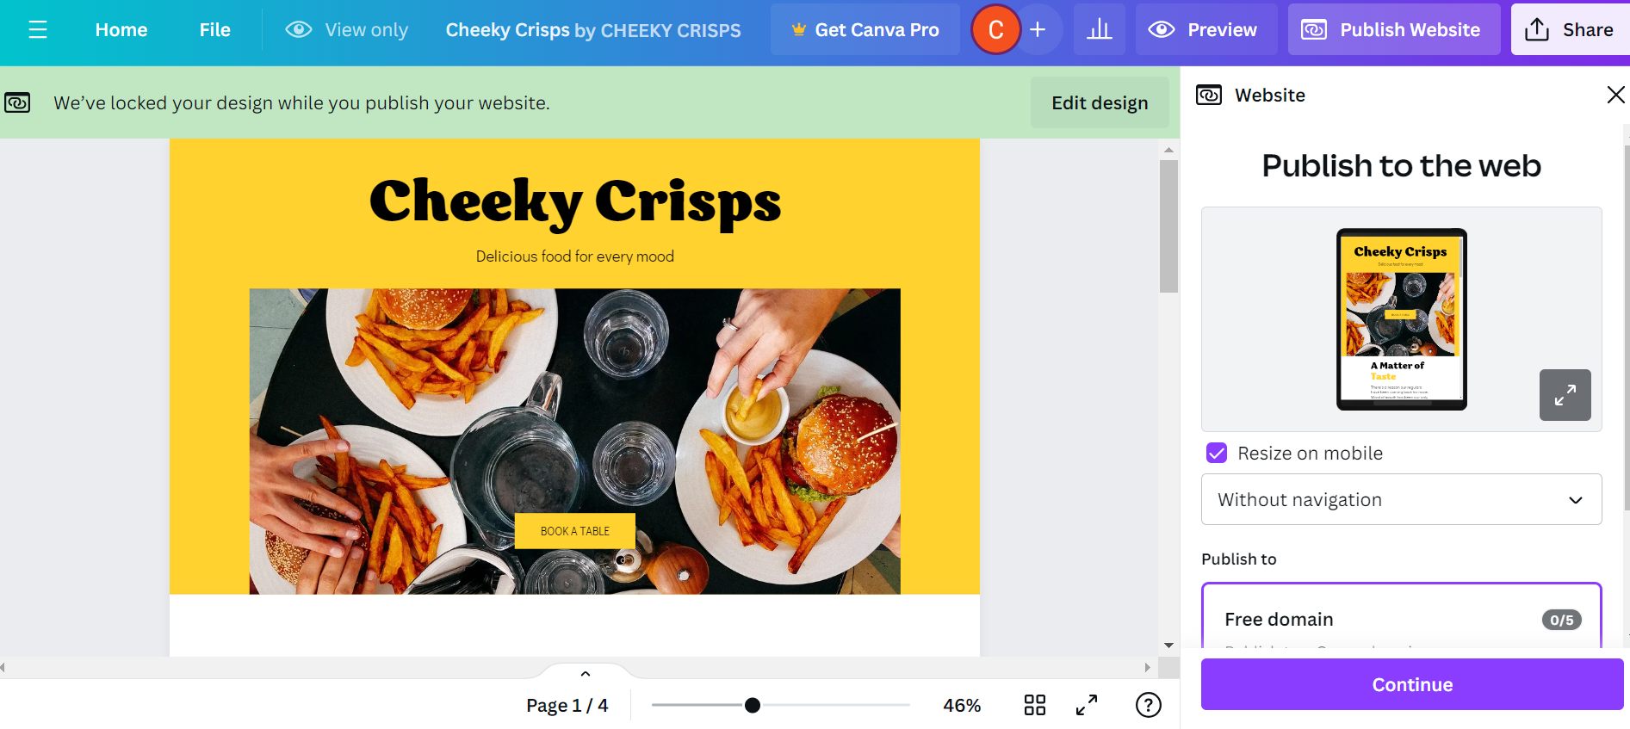

STEP – 8 : CREATING THE URL FOR WEBSITE

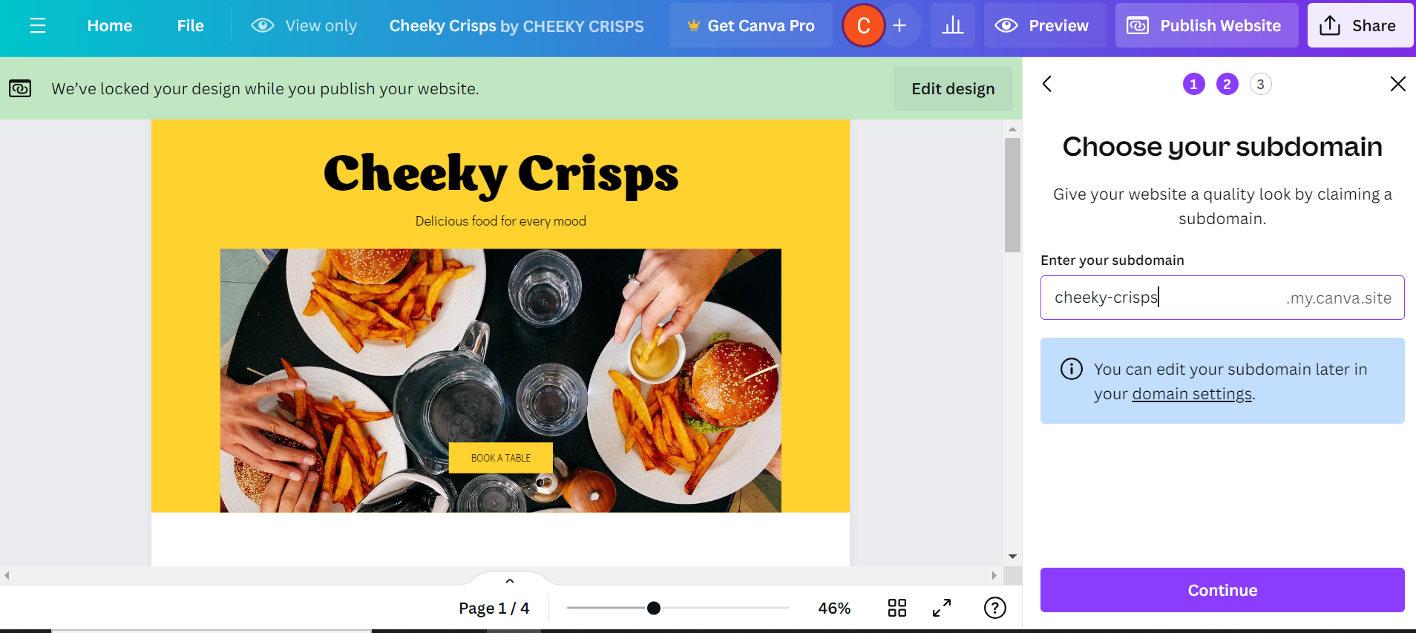

STEP – 9 : DESCRIPTION OF A WEBSITE

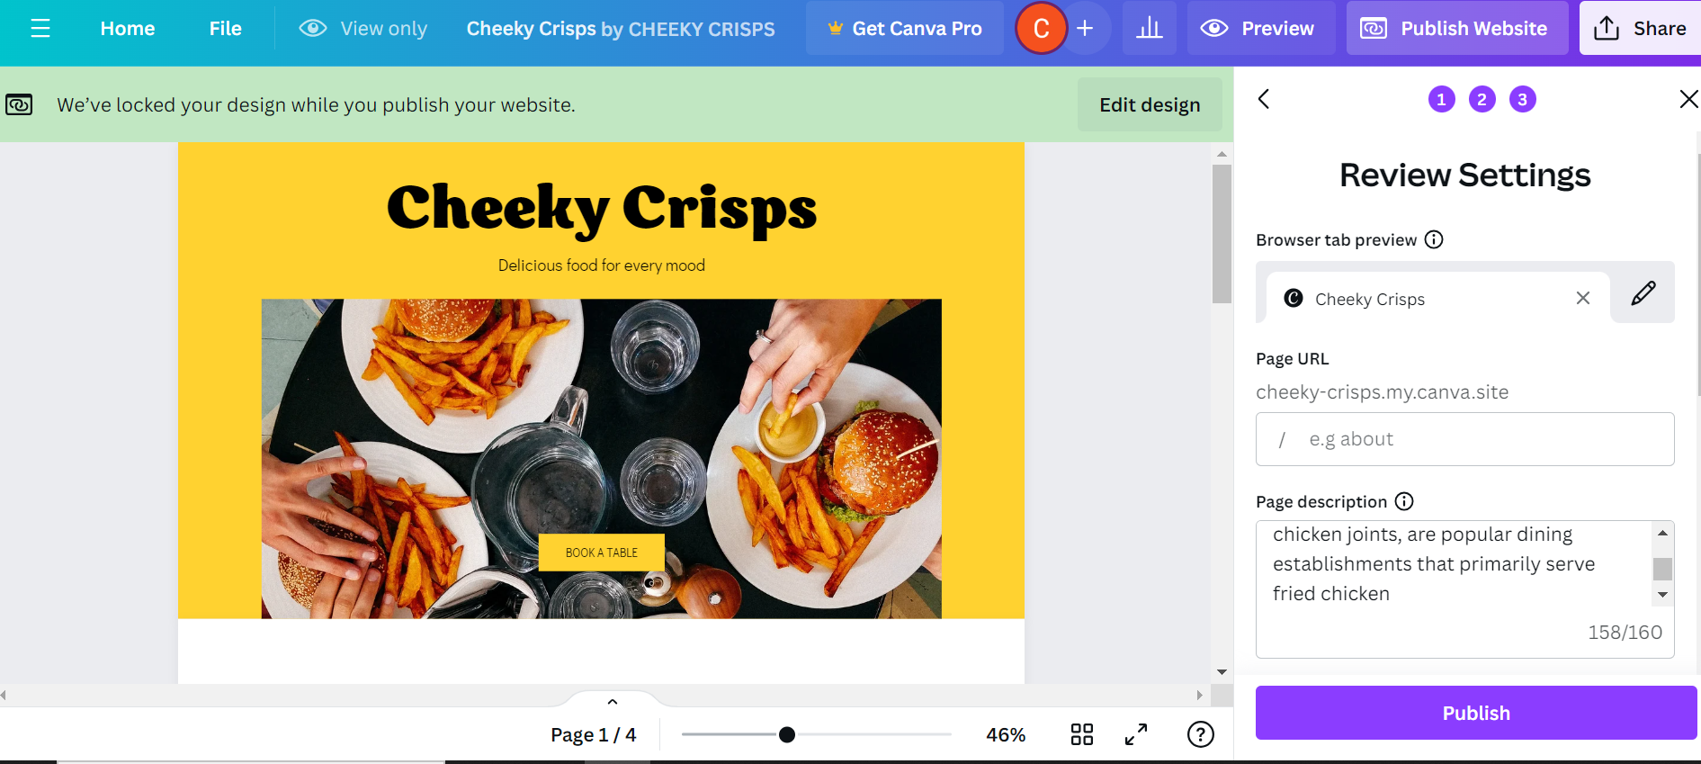

STEP – 10 : PUBLISHING THE WEBSITE

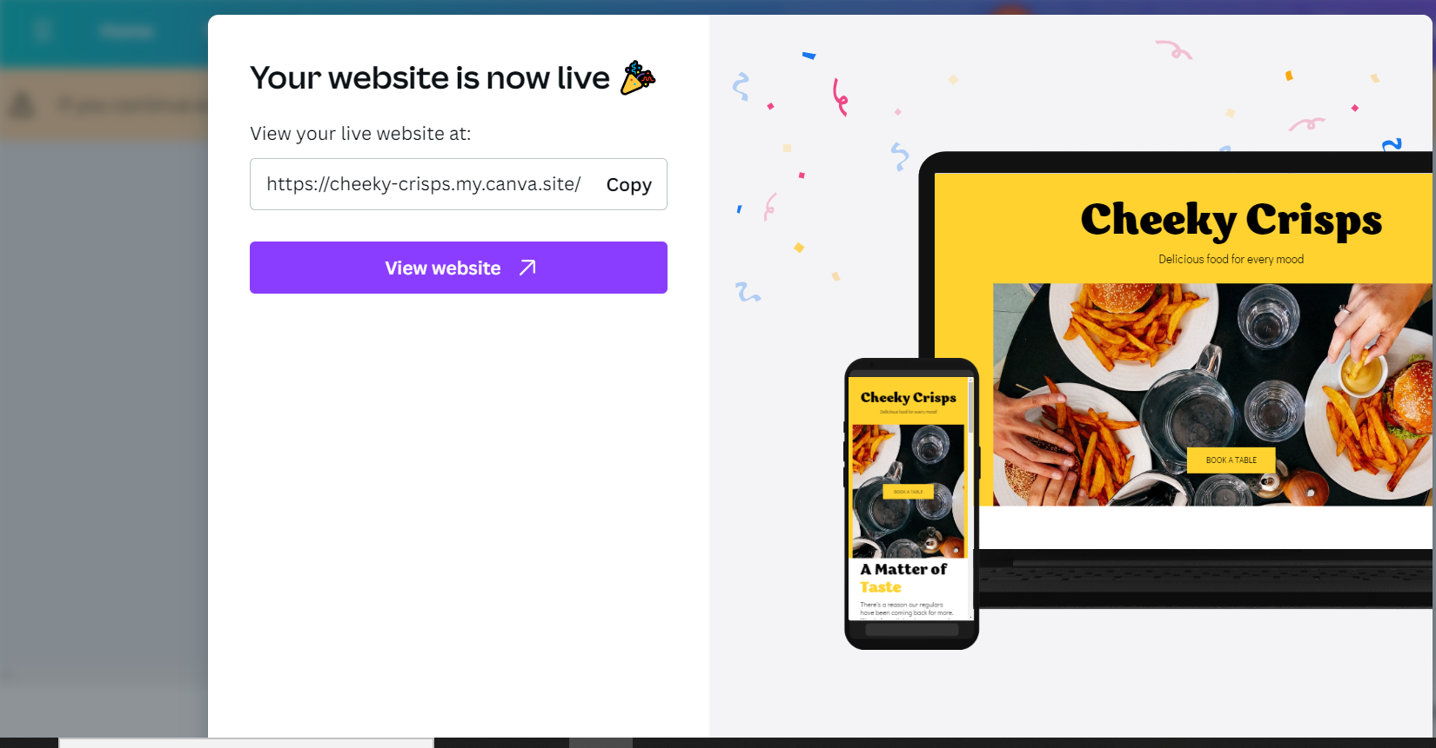

STEP – 11 : VISITING THE WEBSITE

